Full report

An evaluation of the implementation of an evidence based psychological approach in the Third Sector

Anne Joice,
Programme Director

Liz Rafferty,
Education Project Manager
Contents

Section | Title | Page
1 | Summary of project | 3
2 | Introduction  - Pilot Project  - Evidence based Psychological Approach | 5  6
3 | Method | 7
4 | Results | 8
5 | Discussion | 23
6 | Conclusion | 24
7 | Appendices
 | Brief description of the role of the participating organisations | 26
 | Support Staff Focus Groups - Suitability and impact of EBPA with staff | 27
 | Service User Focus Groups - Suitability and impact of EBPA | 34
 | Organisations participating in the pilot | 38
8 | References | 39

Summary of project
This report describes a pilot project to evaluate the implementation of an evidence based psychological approach in the Third Sector.
The aims of the pilot project were to investigate:
- The supporting infrastructure required for the effective implementation of a psychological approach to care within the Third Sector
- The acceptability, suitability and impact of training in a particular evidence-based model for the delivery of psychologically-informed care within the Third Sector
Background
The Scottish Government Mental Health and Protection of Rights Division funded this project in the context of the integration of health and social care. They are interested in promoting psychologically-informed practice in all areas of health and social care, and were also looking to investigate the training needs of this group of staff and particular issues emerging from working with the Third Sector.
NES were asked to evaluate the impact of training Third Sector staff in an existing ‘psychological awareness’ programme which included a basic psychological model of functioning and a range of straightforward tools to support clients to make positive changes in their everyday lives. The aim of the training was to equip the staff with basic psychological knowledge and skills which would enable them to be more effective in their current roles.
NES framed the project through the principles of Implementation Science, seeking to maximise the impact of training by attending both to the educational factors which promote the development of competence, and to the need to engage with the key organisational drivers which determine whether the training is utilised in practice.
Method
The project was designed as a comparison between a standard training intervention (Format B) and the same intervention plus a supportive infrastructure which consisted of pre-training meetings and 4 follow-up coaching groups (Format A)
A mixed methods approach was used to evaluate both training formats, including pre and post training assessments, reflective logs, coaching diaries, semi-structured interviews, focus groups and post-training surveys.
The presence of key implementation drivers within the various participating organisations was assessed.
Following the training, key stakeholders (including the Heads of Psychological Therapies and the Psychological Therapies Training Co-ordinators within the Health Boards) were interviewed and themes that were identified from these meetings were incorporated into the report.

Findings
The impact of training and the effect of an Implementation Science informed approach
- 100 support staff attended training in either Format A (Implementation Science informed) (50%) or Format B (training as usual) (50%), the majority of whom (63%) did not have any previous training in psychological therapies
- Support staff found the training to be acceptable and rated themselves as having achieved their Intended Learning Outcomes (ILO)
- Support staff valued the interactive and experiential format of the training that provided opportunities for behavioural rehearsal.
- While staff who completed both training formats reported using the EBPA materials, greater numbers of staff receiving the IS informed format (Format A) reported using the materials with a client. Within Format A (IS informed), all staff attending the coach groups reported between 60% - 100% use of the materials. The staff who received Format B (traditional) and who responded to the survey (22%) reported lower usage of the materials (50 – 92%).
- The information gathered in the focus groups suggests that the EBPA was considered acceptable and suitable by both Support Staff and Service Users and that there is clear evidence of the impact of the training. It was interesting to note that both staff and clients seek similar qualities in the EBPA; e.g usable approaches that make a difference in people’s lives by facilitating new discoveries and emphasising change.
- The use of Implementation Science tools initiated a dialogue within the third sector organisations regarding the presence of key implementation drivers which are inconsistent within the organisations. The level of connection with Implementation Science principles is low.
Issues which emerged in the course of the pilot project
- There was a unique culture within the five Third Sector organisations that participated in the Implementation Science (IS) informed training (Format A). Support staff expressed a distinct sense of their own identity in working with Service Users that was separate to that of statutory services. They value building relationships with Service Users over a long period of time, providing flexible support as and when Service Users require it, and supporting Service User engagement with statutory services who they feel offer services in a rigid and inflexible way that affects the therapeutic relationship. Any training provided within the Third Sector needs to respect this.
- Service Users greatly valued the flexible support given by Support Staff at the time of most need, at a suitable pace and for an extended period. They also expressed frustration at the rigidity of statutory services.
- Key stakeholders (KS) in the provision of psychological therapies in Scotland welcome greater recognition of a psychological perspective and the potential benefit this could have for people with mental and physical health problems. However there are concerns that insufficient funds may be allocated for the implementation of psychological therapies, appropriate clinical governance arrangements may not be in place and there is confusion regarding what the training equips Third Sector staff to provide.
- There was a recognition that establishing shared values, and a common ethos of evidence-based practice is essential for integrated working around psychological care and therapeutic intervention

Introduction
The integration of Health, Social Care and Third Sector is well underway and is enshrined within the Scottish Government Public Bodies (Joint Working) (Scotland) Act, April 2014. It is widely agreed that greater integration of public services in Scotland is required and that public sector, third sector and private organisations need to work more effectively in partnership with communities and each other, to deliver better services for patients and the public. The need for integrated ways of working is necessary to ensure a seamless service and to provide better outcomes for the users of all services. This agenda requires that all workforces are appropriately trained but also are adequately supported and supervised to deliver a high quality service.
NHS Education for Scotland (NES) is the body that has been tasked with providing training for a wide variety of professionals in Health and Social Care but not previously with regard to the Third Sector. The Scottish Government funded this pilot project between April 2014 and March 2015 to gain a greater understanding of the training needs of this specific workforce and to develop appropriate training to enable staff in the Third Sector to enhance their psychological skills.
Evidence based psychological approaches (EBPA) help people make positive changes in their lives. We know from Implementation Science (IS) that effective evidence based approaches are delivered successfully when effective implementation methods are used within an enabling context, resulting in positive outcomes for people.
Therefore, this pilot project aimed to investigate:
- The supporting infrastructure required for the effective implementation of a psychological approach within the Third Sector.
- The acceptability, suitability and impact of an evidence based psychological model within the Third Sector.

The Pilot Project
The principles of Implementation Science were adopted within the pilot project. IS has a proven methodology that increases the likelihood that training will be embedded and become part of routine practice. Implementation has been defined as ‘a set of activities designed to put into practice an activity or programme of known dimensions’². The National Implementation Research Network have identified a formula for successful implementation: Effective Innovations X Effective Implementation X Enabling Context = Socially Significant Outcomes. Therefore, successful implementation of evidence based psychological approaches requires intervention-level activity and implementation-level activity. Reviews of successfully implemented evidence based psychological approaches have derived common facilitators that ‘drive the engine of change’ and support implementation.
1) Competency Drivers – are mechanisms to develop, improve and sustain one’s ability to implement an approach as intended in order to benefit Service Users
2) Organisation Drivers – are mechanisms to create and sustain hospitable organisational and system environments for effective services
3) Leadership Drivers – focuses on providing the right leadership strategies for the types of leadership challenges. These leadership challenges often emerge as part of the change management process needed to make decisions, provide guidance, and support organisation functioning³

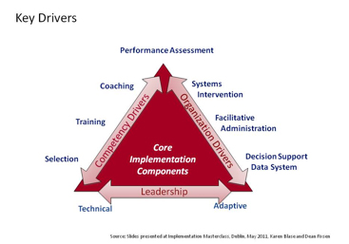
The Evidence Based Psychological Approach
The Five Areas Approach is a widely used self-help method of communicating the basic CBT model. It incorporates a focus on problems of relevance to the person, a structured step by step approach that builds on a supportive relationship with a practitioner, accessible language, and tools that can be utilised by non-specialist practitioners to facilitate change in people with mild to moderate mental health problems. It has been widely implemented in primary care,, and the Third Sector, and was identified as a suitable evidence based psychological approach (EBPA) to use within the pilot.

Method
The EBPA was implemented in a range of Third Sector organisations in 2 formats:
A. IS informed - 2-day interactive workshops plus a supportive infrastructure that consists of pre-training meetings and 4 follow-up coaching groups
B. Traditional - 2-day interactive workshops and no supportive infrastructure.
A mixed methods approach was used to evaluate both training formats. Restrictions in time and access to staff have limited the methods that have been used with each training format.
The 2-day interactive training in both training formats (A & B) was evaluated with pre and post training assessments that identified demographics of staff, their self-rated level of knowledge of psychological approach, their view on the acceptability of the training, and their self-rated attainment of Intended Learning Outcomes (ILO).
- Format A - Semi –structured interviews were carried out with participating Third Sector organisations receiving the training with a supportive infrastructure (Format A). The presence of key implementation drivers within the organisation at the exploration stage of implementation and prior to training being delivered was assessed with the National Implementation Research Network (NIRN) Assessment of Best Practice. The assessment measured the extent to which best practices associated with each of the following implementation drivers was in place, partially in place, or not in place.
Following the delivery of the psychological approach training and coaching sessions (Format A), focus groups were carried out to analyse the experience and impact of the training for staff and Service Users. A sample of participants received objective pre and post assessments of attitudes and knowledge in EBPA. Coaching notes kept by the trainer and reflective logs kept by the participants were reviewed. A thematic analysis was carried out on the data from the interviews, focus groups, coaching notes and reflective logs to identify superordinate and subordinate themes.
- Format B - A post-training survey was sent to participants who received Format B training 2 months following the training. This included self rating of the ILO and invited feedback on their experience of the training and their use of the EBPA materials.
Key stakeholders (such as Head of Psychological Therapies and Psychological Therapy Training Co-ordinators) were interviewed and the themes that were identified from these meetings were incorporated into the report.
A stakeholder event for Third Sector organisations was held on the 26th August 2014 to promote the pilot and invite Third Sector organisations to participate. All organisations that attended the event expressed an interest in participating, but as this was a limited pilot 4 were offered Format A, and the others were offered Format B. The organisations that were offered Format A were: Carrgomm, Lanarkshire Association for Mental Health (LAMH), Penumbra – North, Scottish Association for Mental Health (SAMH) – South and Scottish Association for Mental Health (SAMH) – North.

Results
144 staff expressed an interest in attending training, 105 (72%) staff were offered training in the EBPA in either Format A (50%) or Format B (50%), and 100 staff attended the training giving a 95% attendance rate.
144 staff registered interest in attending the training

Format B
52 staff were offered places
48 staff attended 2 days of training
Format A
53 staff were offered places
52 staff attended 2 days of training

The majority of the staff (63%) attending the training did not have any previous training in Psychological Approaches (Table 1). Some participants had a qualification in Cognitive Behavioural Therapy (1%) or Counselling (7%) and a number of Occupational Therapy graduates had undertaken a 12 week module in Cognitive Behavioural Approaches within their professional qualification (7%).

Table 1 – Previous knowledge of psychological approaches

PSI training | Frequency | Percent
No training | 90 | 62%
Guided self-help training | 10 | 7%
Short course (1 – 5 days) | 13 | 9%
Short course (5 – 12 days) | 2 | 1.4%
Certificate at SCQF 7 (40 credits) | 10 | 7%
PG Certificate PSI (60 credits) | 2 | 1.4%
Diploma PSI (120 credits) | 2 | 1.4%
Masters PSI (180 credits | 4 | 3%
Module in undergraduate programme (20 credits) | 10 | 7%
Missing data | 1 | 0.70%
Total | 144 | 100%

74% of participants reported not receiving clinical supervision in psychological approaches. 19% do receive supervision and 7% stated that clinical supervision forms part of their line management supervision arrangements.

Post training ratings for Format A & B
Overall, across the 5 participating organisations in Format A the training was rated as being acceptable to highly acceptable (Table 2), while in Format B the training was rated as being acceptable to staff.
Table 2 – Training Acceptability Rating (TARS) Overall Scores

 |  | TARS Content Overall Score (%) | TARS Process Overall Score (%) | TARS Combined Overall Score (%)
Format A  (n = 52) | Organisation 1 | 91.94 | 93.19 | 92.59
 | Organisation 2 | 90.87 | 84.13 | 87.50
 | Organisation 3 | 90.20 | 87.36 | 88.78
 | Organisation 4 | 88.54 | 80.60 | 84.61
 | Organisation 5 | 94.44 | 91.67 | 93.06
Format B  (n = 48) | January Session | 87.34 | 85.22 | 86.29
 | March Session | 88.50 | 91.32 | 89.95

Table 3 provides the ratings that individuals provided on their Intended Learning Outcomes before and after the training. Participants in both Format A & B were more likely to agree that they had achieved their learning outcomes following the training.
Henceforth, the results for Format A & B are presented separately in this report

Table 3 - Self – rated Intended Learning Outcomes

 |  | Format A (n =52) |  |  |  |  |  | Format B (n = 48)
 |  | Strongly agree | Moderately agree | Slightly agree | Slightly disagree | Moderately disagree | Strongly disagree | Strongly agree | Moderately agree | Slightly agree | Slightly disagree | Moderately disagree | Strongly disagree
I have developed a good understanding of an evidence based psychological approach | Pre | 2 | 17 | 22 | 5 | 4 | - | 2 | 31 | 42 | 8 | 6 | -
 | Post | 24 | 21 | 5 | 2 | - | - | 16 | 27 | 4 | 1 | - | -
I can identify thought, feelings and behaviours and how they affect people | Pre | 9 | 28 | 10 | 1 | 2 | - | 13 | 59 | 17 | - | - | -
 | Post | 29 | 19 | 2 | 1 | 1 |  | 22 | 23 | 3 | - | - | -
I have a good understanding of an evidence based psychological assessment that can be used to develop a shared understanding of people’s difficulties | Pre | 3 | 17 | 21 | 4 | 5 | - | 2 | 32 | 32 | 13 | 10 | -
 | Post | 22 | 19 | 9 | 1 | 1 | - | 18 | 25 | 5 | - | -
I am able to develop a plan to work on together and select approaches to make effective change | Pre | 6 | 26 | 16 | 2 | - | - | 10 | 43 | 30 | 4 | 2 | -
 | Post | 25 | 19 | 8 | - | - | - | 17 | 25 | 4 | 2 | - | -

Format A
Organisational Culture within participating Third Sector Organisations
Information on the background of the participating Third Sector organisations is provided in Appendix 1. All staff working in the Third Sector organisations expressed a distinct sense of their own identity in working with Service Users that was separate to that of statutory services. They value building relationships with Service Users over a long period of time and providing flexible support as and when Service Users require it.
‘They (LAMH) do what the situation needs. They make it feel personal; there is genuineness’ (Service User 1, LAMH).
The organisations and the Service Users expressed a view that statutory organisations offer services in a rigid and inflexible way that affects the therapeutic relationship.
‘N’s had the experiences with therapy in the past and that relationship, what was it, once a week you were seeing a therapist. And there’s a barrier there. I’ve been working with Neil for two years, so we already had that relationship in place...’ (Participant 5, SAMH South).
Support Workers viewed part of their role as supporting service user engagement with statutory organisations.
‘I’ve supported other people to other appointments and stuff, and they very much have prepared the night before in their head they think, I’m going to say this to her because... yeah, it’s what I should be saying, it’s an official appointment that I’m turning up for. Yes doctor, no doctor, yes nurse. Whereas there isn’t that with... we’ve got a closeness that’s not there.’ (Participant 8, SAMH South).
Services Users expressed frustration at the rationing of services when time limits are applied and instructions; such as not telephoning for an appointment or not answering the door for scheduled appointments, result in discharge.
‘I was always getting discharged because I didn’t phone up for an appointment. I was hiding in cupboards when people from the team came out and knocked on my door, I would stay in bed and get really suicidal.’ (Service User 1, LAMH).
‘I was getting help and then all of a sudden it was gone...’ (Service User 2, Carrgomm).
The Service Users previous experience of treatment delivered from the NHS was insufficient to meet their needs.
‘I had so much counselling, counselling, counselling, but when you go home and you shut the door it’s just you and the four walls...’ (Service User 1, SAMH South).
‘Cause I had counselling, but you’re only allowed 8 sessions then you’re dropped.’ (Service User 2, Carrgomm).
In contrast the Service Users and staff of Third Sector Organisations described the support given and received through the various participating organisations, as more flexible, with people given the time they need, at a suitable pace and for an extended period. The extracts suggested that there is a perception of a more genuine relationship between the Service Users and the staff from the Third Sector, which made engagement with this service easier.

‘where Carrgomm , they sort of... they can do it longer with you and , you know... and they do it at your pace, which I found quite good’ (Service User 2, Carrgomm).
‘I’m not sure why but I engaged with LAMH and I have been coming here for 10 years’ Service User 1, LAMH.
‘but you get the push, you get the push from Carrgomm, do you know what I mean?’ (Service User 2, Carrgomm).
‘Oh I got this book the CPN gave me, I’ve not opened it’ (Participant 2, Carrgomm).
Staff participating in the training and coach groups were clear about the boundaries between health care and social support and understood that the training would not equip them to be CBT Therapists.

Themes identified from meetings with key stakeholders for Psychological Therapy services
Key stakeholders (KS) in the provision of psychological therapies in Scotland (KS) welcome greater recognition of a psychological perspective and the potential benefit this could have for people with mental and physical health problems. Increased psychological awareness could lead to a more compassionate response from services and greater empathy to the life circumstances that people experience. It could also lead to a more enquiring approach to people’s health problems. Any developments that promote integration with NHS, Social Services and the Third Sector should be made with full consultation and discussion with the Heads of Psychology in Scotland. It is important to recognise the expertise of others in taking forward new initiatives.
There are concerns that the provision of psychological therapies and interventions may be delegated to Third Sector organisations as a cheaper alternative to statutory health services. Insufficient funds may be allocated to ensure that staff with the right qualifications, skills and experience are employed to provide psychological therapies and interventions as identified in the Matrix. In addition to this, the funding arrangements of Independent and Third Sector organisations can influence organisational cultures and their approach to partnership relationships. Often acquisition of knowledge and skills in psychological therapies and interventions is perceived to make an organisation more competitive in obtaining funding.
Providing training to increase psychological awareness provides challenges for staff in the NHS, Social Services and Third Sector Organisations in terms of knowing what to do when awareness is raised. Any training that NES is providing to staff working in the NHS, Social Services or the Third Sector should clearly identify both the expectations for staff, and the therapies and interventions that staff will be equipped to provide following the training. A distinction needs to be made between providing ‘low intensity psychological interventions’ and ‘psychological awareness’. Further definition and clarification of Psychological Awareness may be helpful in taking forward a psychological awareness raising initiative. Local governance arrangements need to be put in place to help facilitate this process.
Across the NHS, Social Services and Third Sector there is diversity in the level of evidence that supports the provision of psychological therapies and interventions, and the selection of appropriate interventions to meet people’s needs. KS are concerned that interventions could be offered to people, to help with their mental health problems that are not evidence based and could be harmful to people. Training should be supported with local clinical governance arrangements. Furthermore, there is diversity in the qualifications, professional experience and expertise and life experience that staff have working in the NHS, Social Services and Third Sector. Occasionally, assumptions are made about parity that is not helpful or accurate. There are a range of clinical governance issues that need to be clarified within integrated organisations to ensure the safe and effective provision of psychological therapies and interventions, such as;
- the appropriate training & qualifications required to provide psychological therapies and interventions
- the appropriate supervision to monitor that staff are ‘adhering to the model’ that they were trained to deliver
The process of selecting a psychological awareness raising approach that is to be rolled out across Scotland should involve:
- Speaking to a range of people and consulting with people who have expertise in psychological therapies and interventions.
- An open and transparent process should be followed in selecting any psychological awareness raising approach tools that would be used.
- As far as possible, any psychological awareness raising approach should be evidence based, tried and tested.
Considering the diversity in the educational backgrounds and life experience of staff across the NHS, Social Services and Third Sector organisations, training in the Psychological Awareness should be based on individual need and not needs identified across the organisation.

Perception of the presence of implementation drivers within organisations
Table 4 summarises the Implementation Driver scores from each organisation that received training in Format A. A score of 1.5 is regarded as the threshold for high quality implementation. The organisations had a tendency to focus on implementation drivers that were present in their organisation for the overall functioning of the organisation and not the implementation of the psychological approach. Managers completing the Best Practice Assessment had limited connection with the drivers that are required for effective implementation.
Table 4 – Implementation Drivers within the organisations

Implementation Driver | Organisation 1 | Organisation 2 | Organisation 3 | Organisation 4 | Organisation 5
Selection | 1.33 | 1.11 | 0.89 | 0.56 | 0.89
Training | 2.00 | 1.60 | 1.60 | 1.60 | 1.80
Coaching | 1.38 | 0.77 | 0.00 | 0.69 | 0.31
Performance Assessment | 1.33 | 0.22 | 0.56 | 0.89 | 0.00
Systems Approach | 1.25 | 1.50 | 1.13 | 1.13 | 0.38
Facilitative Administration | 1.86 | 1.57 | 0.86 | 0.71 | 0.00
Decision Support Data System | 1.20 | 1.30 | 0.30 | 0.80 | 0.30
Technical Leadership | 1.20 | 1.00 | 0.80 | 0.40 | 1.80
Adaptive Leadership | 0.13 | 0.25 | 0.63 | 0.50 | 1.50

The EBPA was rated by leaders within the Third Sector Organisations and considered to meet the needs of the Service Users, fit with current initiatives, be sufficiently resourced, evidence based, ready of replication and to have sufficient capacity to implement.
Table 4 - Hexagon Tool
 | Org 1 | Org 2 | Org 3 | Org 4 | Org 5
Need | 5.00 | 4.00 | 5.00 | 3.00 | 4.00
Fit | 4.00 | 4.00 | 5.00 | 3.00 | 4.00
Resources | 4.00 | 4.00 | 1.00 | 5.00 | 3.00
Evidence | 3.00 | 4.00 | 2.00 | 4.00 | 4.00
Readiness | 3.00 | 5.00 | 2.00 | 3.00 | 3.00
Capacity | 4.00 | 4.00 | 3.00 | 4.00 | 4.00
Total | 23.00 | 25.00 | 18.00 | 22.00 | 22.00
Staff Coaching Groups
Table 6 illustrates the number of Support Workers attending each coaching session across the participating organisations. 48 (90%) initially attended the coaching groups. Attendance at the coach groups drops with each session until approximately 50% of staff were attending.

Table 6 – Staff attendance and use of EBPA across coaching groups

Organisation and session | Number of  Support Workers | Number not  used materials | Number used materials | % of  use
Organisation 1
Session 1 | 8 | 8 | 0 | 0%
Session 2 | 5 | 0 | 5 | 100%
Session 3 | 5 | 0 | 5 | 100%
Session 4 | 4 | 0 | 4 | 100%
Organisation 2
Session 1 | 5 | 2 | 3 | 60%
Session 2 | 3 | 1 | 2 | 66.6%
Session 3 | 3 | 1 | 2 | 66.6%
Session 4 | 3 | 2 | 1 | 25%
Organisation 3
Session 1 | 4 | 3 | 1 | 25%
Session 2 | 7 | 3 | 4 | 57%
Session 3 | 8 | 5 | 3 | 37.5%
Session 4 | 7 | 5 | 2 | 28.5%
Organisation 4
Session 1 | 21 | 21 | 0 | 0%
Session 2 | 16 | 9 | 7 | 43.7%
Session 3 | 10 | 5 | 5 | 50%
Session 4 | 12 | 4 | 8 | 66.6%
Session 5 | 10 | 4 | 6 | 60%
Organisation 5
Session 1 | 10 | 10 | 0 | 0%
Session 2 | 3 | 1 | 2 | 66.6%
Session 3 | 4 | 2 | 2 | 50%
Session 4 | 3 | 0 | 3 | 100%

Table 6 also provides information on the use of the materials. There is a general trend for there to be a low use of the materials at the first coaching session, despite this being the most highly attended session. The main reason given for the limited use was there had not been enough time to use the approach as the first coaching session was generally held quite quickly following the training. By the second and third sessions, more Support Workers report use of the materials.

Reflective logs from staff working in three of the organisations were reviewed to identify which worksheets were used most. Table 7 shows which worksheets were used and how many Service Users the approach was used with. In two of the organisations usage reduced in later sessions.

Table 7 – Use of worksheets

Worksheet | Organisation 1 | Organisation 2 | Organisation 3 | Overall  Total
Vicious Circle | 16 | 4 | 28 | 48 (25%)
The Cards Life Deals you | 1 | 1 | 14 | 16 (8%)
Before/after we got going | 3 | 0 | 12 | 15 (8%)
10 Things that make you happier right away | 3 | 1 | 11 | 15 (8%)
Plan, do and Review  (OK – How did it go?) | 5 | 4 | 13 | 22 (11%)
My Activity Planner  (Don’t just sit there, make a plan) | 1 | 1 | 8 | 10 (5%)
My Bad Thoughts | 6 | 2 | 10 | 18 (9%)
Bad Thought Spotter | 4 | 2 | 12 | 18 (9%)
The Amazing Bad Thought Busting Programme (ABTBP) |  | 2 | 7 | 9 (5%)
My Easy 4-Step Plan (E4SP) |  | 0 | 5 | 5 (3%)
The Things You do that Mess you up | 1 | 0 | 2 | 3 (2%)
Know your Buttons | 2 | 0 | 5 | 7 (4%)
Total Sheets Used | 42 | 17 | 127 | 186 (100%)
Number of Service Users | 17 | 7 | 31 | 55

Suitability and impact of EBPA with staff

Focus groups were carried out in each of the organisations participating in Format A of the pilot project. The analysis detailed a number of current themes – further information is available in Appendix 2.
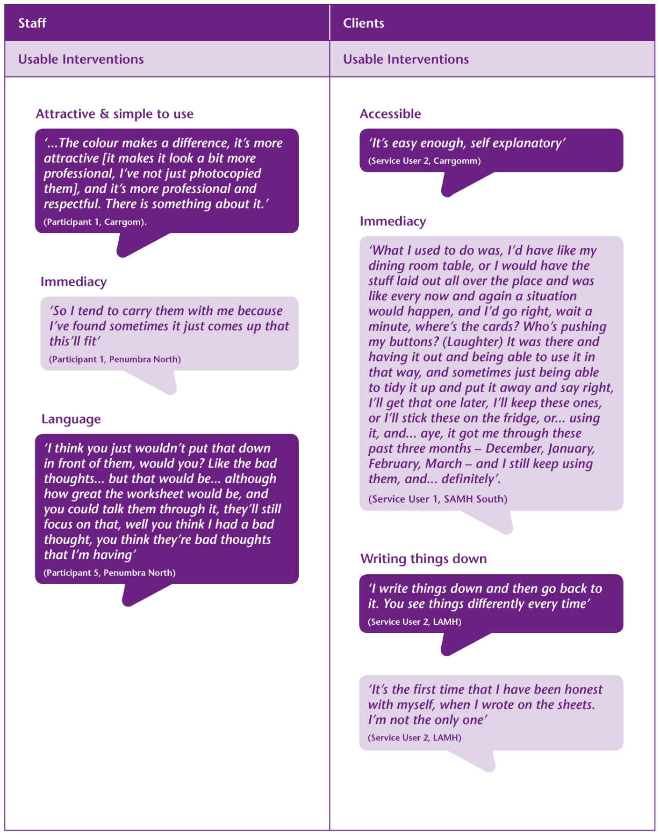
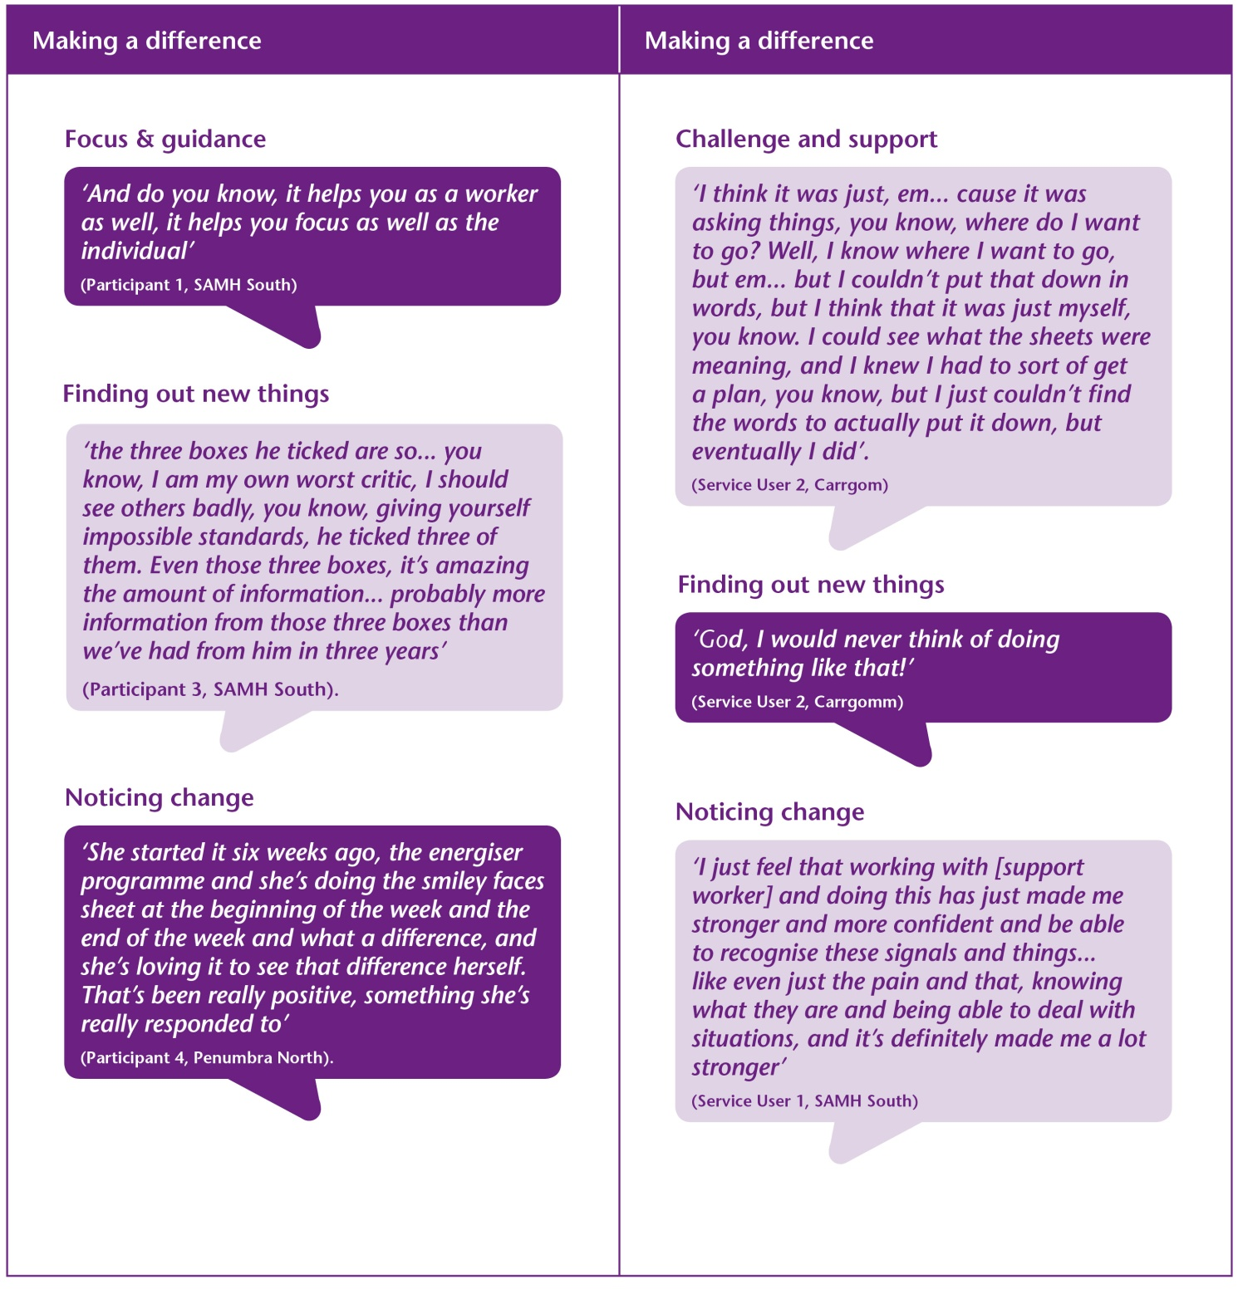
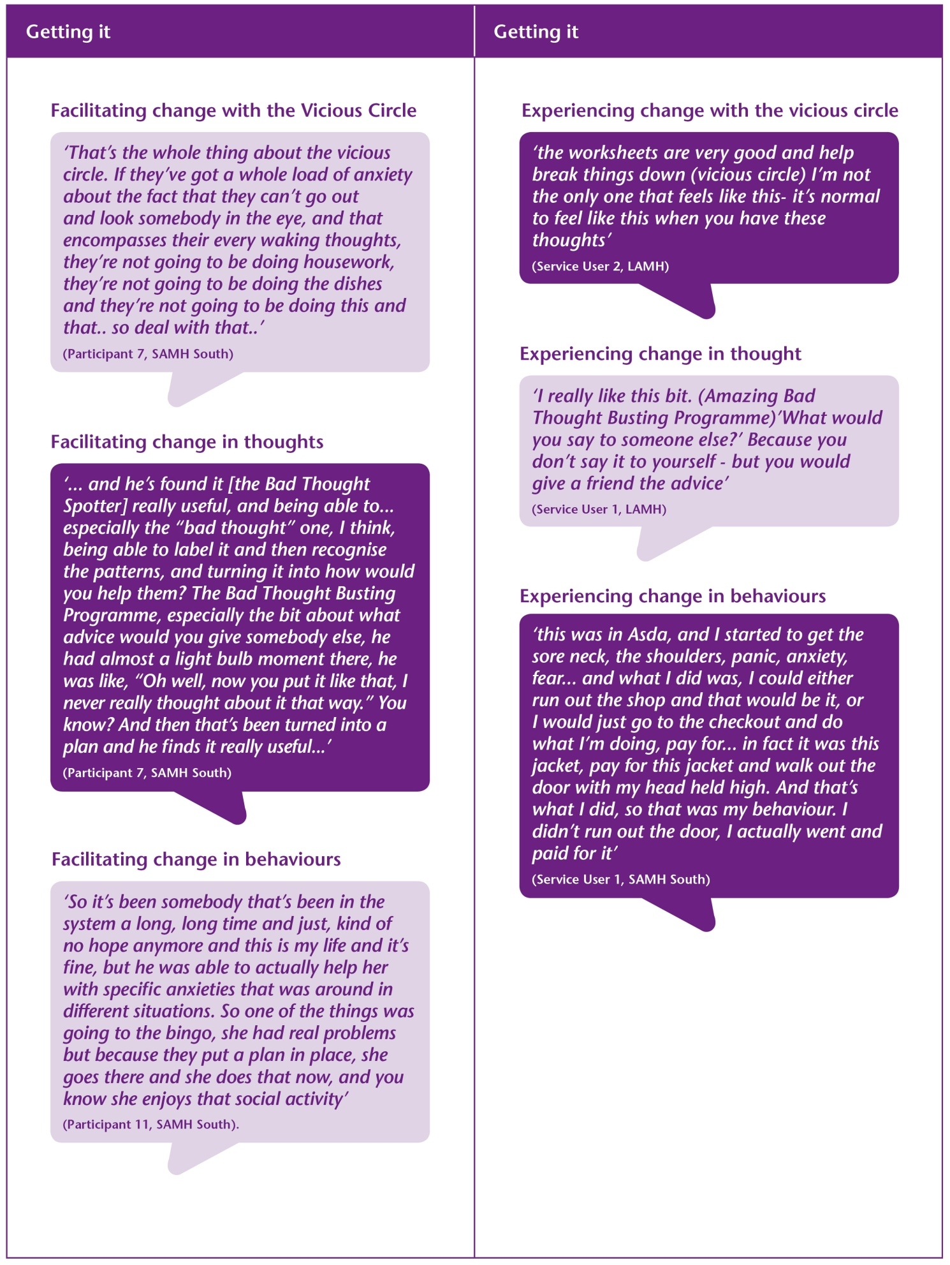
Format B
19 (40%) staff responded to the on-line survey that was distributed following the 2-day training. However within the survey only 11 (22%) reported on their use of the EBPA worksheets (Table 8).
Table 8 – Self – reported use of EBPA worksheets

Worksheet | Frequency | All of the time | Occasionally | Never
Vicious Circle | 11 | 9% | 45% | 45%
The Cards That Life Deals You | 12 | - | 50% | 50%
Before / After we Got Going | 11 | 9% | 54% | 36%
10 Things That Make You Happier Right Away | 11 | 9% | 54% | 36%
Plan, Do, Review  (OK – How did it go?) | 11 | 27% | 54% | 18%
My Activity Planner  (Don’t just sit there, make a plan) | 12 | 25% | 67% | 8%
My Bad Thoughts | 12 | 25% | 25% | 50%
Bad Thought Spotter | 12 | 25% | 25% | 50%
The Amazing Thought Busting Programme (The ATBP) | 12 | 17% | 33% | 50%
My Easy 4-Step Plan (My E4SP) | 12 | 33% | 25% | 42%
The Things You Do That Mess You Up | 12 | 25% | 42% | 33%
Know Your Buttons | 11 | 36% | 36% | 27%
Anxiety Control Sheet | 12 | 8% | 58% | 33%

54% of the responders felt that the EBPA had made a difference to the way in which they worked with their Service Users. Responders thought that the EBPA gave ‘more positive outcomes and increased confidence in materials’ but it is not known how this was determined.
Responders thought the EBPA helped improve the collaborative relationship they had with their Service Users;
‘It gives my Service Users more involvement with their planning, and allows them to communicate more effectively’
Using the EBPA was considered to improve the focus of their approach with their Service Users;
‘It helps keep the sessions focussed and engaging’
‘It provides a focus to our involvement and gives the service user (in our case unpaid carers) an opportunity to make choices to change behaviour/responses to situations in order to improve their wellbeing. The vicious circle analogy helps carers to see that what is 'out there' is often not at all within their control; but how they deal with their own feelings and thoughts about it is.’
The EBPA approach was thought to improve the understanding of the causes of problems;
‘Understanding the difference between thoughts, feelings, physical feelings and behaviours. Helping to recognise that thoughts and feelings can be the cause of the behaviour. Having tools to see what keeps us feeling good and making sure we use them’
‘Helps people focus having something tangible in front of them. Breaks things down into manageable areas on knowledge and information. People recognise what they normally do and it gives them ideas on how to go about changing them’
The EBPA was considered to be a good fit with existing resources in use within their organisation;
‘Having additional useful resources that can be used in conjunction with other wellness tools e.g. WRAP (Wellness and Recovery Plans), Penumbra "My Plan" etc.’
Some of the language used within the materials was off-putting
‘I'm not so keen on the word 'bad' - I think 'unhelpful' is a better word to describe the negative thoughts. Some people can take the word 'bad' too literally as a reflection of themselves, especially if they are a bit confused already - I work mainly with people with alcohol difficulties’
Some responders felt that the training itself reinforced their pre-existing knowledge;
‘I think it has brought into focus some of the ways that I already work and augmented these’

Discussion
The overall aim of this project has been to implement an evidence based psychological approach that can increase the psychological awareness and overall understanding of psychological problems, which in turn assists staff in the Third Sector to be more effective in their job roles.
There is a distinct organisational culture that needs to be respected within Third Sector Organisations. Providing good quality person-centred care at the right time for an individual is highly valued. Similarly, Service Users greatly value the help they receive from the organisations. There was a high level of ‘buy in’² within the participating organisations but the science of implementation is a relatively new concept for Third Sector Organisations. The use of the Assessment of Best Practice tool initiated an essential dialogue within the Third Sector organisations on the importance of key implementation components. However, this is the first iteration of this dialogue and should not be viewed as permanent and unchanging. The results from the assessment demonstrate that key implementation drivers are inconsistent within the organisations. Preparation that involves developing an understanding of the local context, mobilisation of interest, consensus and support, and clarity around feasibility is required for the effective implementation of an EBPA within the Third Sector
The EBPA was implemented to current staff working within the organisations who had very little previous knowledge of EBPA. The results show that the training was acceptable to staff and that the Intended Learning Outcomes were achieved. The results also fit with literature on professional development in that Support Workers valued the interactive and experiential format of the training that provided opportunities for behavioural rehearsal. They found the training and coaching groups were both challenging and supportive in encouraging them to put their learning into practice.
Support Staff in both training formats were highly motivated to implement EBPA. While staff who completed both training formats reported using the materials, greater numbers of staff receiving the IS informed format (Format A) reported using the materials with a client. Within Format A (IS informed), 100% staff attending the coach groups reported between 60% - 100% use of the materials. The staff who received Format B (traditional) and who responded to the survey reported lower usage of the materials. This fits with previous studies within mental health where coaching groups were found to be critical for staff implementing the EBPA. Enthusiasm and confidence increased as the Support Workers received positive responses from Service Users. Another key factor that helped the Support Workers try out the approach was feedback from their peers. If during the coaching session a colleague described how they had used a worksheet, and it had gone well, this made others think it might work for them too. Timing would also appear to be critical; coaching groups need to be organised to follow close to the end of training. If there is a longer gap there is a danger that the Support Workers may find their memory of the approach fading and they may quickly lose confidence.

It is interesting to note the EBPA worksheets that Support Workers felt more confident in using. The ‘Vicious Circle’ and Behavioural Activation worksheets were more likely to be used. These resources increase the joint understanding between the Support Worker and the Service User of a person’s problems and help them set goals to overcome them. The resources that were less likely to be used were the worksheets for working with a person’s thoughts and cognitions, but this may be due to the language being perceived as off-putting.
The information gathered in the focus groups suggests that the EBPA was considered acceptable and suitable by both Support Staff and their clients. Staff found the materials to be bright, colourful, visually attractive and professional in appearance. They valued the focus, structure and guidance that they provided. However, the use of dark colours and pejorative language was off-putting. The EBPA materials were considered to be very personalised and fitted with the person-centred culture of the Third Sector Organisations.
Use of the materials was reinforced by the difference that they made to their clients through gaining new information and insights into their problems. The EBPA appeared to enhance the existing relationship with the clients and revitalise the work they did together. It helped staff notice changes that their clients were making. Initially staff were reluctant to ask their clients to write things down but noted that although it was challenging it helped people gain a different perspective on problems. This knowledge and understanding helped Support Workers offer help in ways that were more effective for their clients. Some staff chose not to use the worksheets with their clients but were guided by the materials ‘in their heads’. Some staff also identified that the EBPA may not be relevant for all their Service Users with complex severe and enduring mental health problems. Therefore, any EBPA that is be used in the Third Sector should:
- Be clear and easy to use
- Provide guidance to staff and clients
- Use engaging language
Using paper based EBPA materials is likely to increase the admin burden on Third Sector organisations to ensure that regular supplies of relevant materials are available. There are limitations in the digital support that can be provided due to the level of IT resource that is available in the Third Sector.
The focus groups carried out with staff from Format A and their Service Users demonstrated clear evidence of the impact of the training. The support staff were able to provide coherent examples of use of the Vicious Circle, Behavioural Worksheets and Thoughts Worksheets. In addition to this, the Service Users that attended the focus groups were able to provide clear examples of their use of the EBPA materials to improve their wellbeing and the impact of the training.
Due to the limitations of the methods in this pilot there is incomplete information available on the impact of the implementation of the EBPA with the staff that received Format B. Further work is required to identify if similar themes are apparent with this group of staff and their clients.

Conclusion
The staff within both training formats were highly motivated to implement EBPA. However, it appears that the supporting infrastructure that is required for the effective delivery of EBPA is inconsistent and variable within each Third Sector organisation and presents challenges for the effective implementation of EBPA. The results show that training was acceptable to staff and the Intended Learning Outcomes were achieved. The focus groups carried out with staff from Format A and their Service Users demonstrated clear evidence of the impact of the training. It was interesting to note that both staff and Service Users seek similar qualities in the EBPA; e.g. usable approach that make a difference in people’s lives by facilitating new discoveries and emphasising change.

Lessons Learned / Future Recommendations
The outcomes of the pilot project may be useful for NES in identifying the supporting infrastructure, training needs and psychological model that fits with the Third Sector.

Appendix 1
Brief description of the role of the participating organisations (Format A)
Organisation 1- is a Scottish Charity which provides Social Care and Community Development Services in 13 Local Authority areas in Scotland. They support people ‘who want help to live their lives as they choose and be as well as they can be in the presence of Mental Health Problems, Disabilities, Ill health and Old Age’. Staff involved in the pilot study all worked in the Integrated Mental Health Services for each of the three Community Health Partnerships in Glasgow. Support is provided to:
- Primary Care Mental Health services – Community Bridge Building which aims at helping people get back into doing what matters to them outside their home.
- Community Mental Health Teams – social care support for people in crisis as an alternative to hospital admission and Assertive Outreach to support people who find it difficult to engage with services.
Organisation 2 - provides community based support services to adults with mental health problems. Currently the organisation provides a variety of support services, including home based support, group support, support in local community facilities, employability support, out of hour’s crisis services, a mental health & wellbeing information resource and a local charity shop.

Organisation 3 - supports recovery, social inclusion, and employment by building confidence, skills, promoting work, education, training and leisure opportunities. The service is community based and maximises use of ordinary resources and enables people to regain their lives independent of services. The overall focus of the project is to enable people to identify areas in their lives they want to improve, issues they want to address and opportunities they want to achieve. People work alongside the staff team and develop and build up their own outcome recovery focussed plans. These plans are made and developed through the Penumbra HOPE toolkit© to assist people to take the steps they want to take to enable themselves to recover from a mental health problem. Moreover, throughout the planning process a person comes through with the service they importantly learn ways to sustain recovery; self manage and stay well in their everyday lives.

Organisation 4 & 5 - provides a range of community based services including; registered care homes for people with severe and enduring mental health problems and ARBD; care at home/housing support services for people with medium to high level support needs supporting their mental health, addiction and homelessness issues; day services for drug and alcohol recovery based programmes and employment and learning programmes and services.

Appendix 2
Support Staff Focus Groups
Suitability and impact of EBPA with staff

Usable approach
There were a range of qualities within the EBPA worksheets that were valued by the Support Workers and increased the likelihood of their use. The simplicity of the materials was helpful in that they were understandable for both the Support Worker and the Service User; ...‘when I’d shown the Service User the sheets, right away he was interested cause it was really quite simple for him...’ (Participant 3, SAMH North). It was important to staff that the materials were convenient and professional; ‘I think it’s about making it convenient and easy to use, and something that you feel good about taking out.’ (Participant 1, Carrgomm). The materials were considered to be very colourful, visual and attractive;
...‘I think because this was quite a visual way for her to look at paperwork, she’s more interested in the goals section now and my plan, so I think it’s just kind of reignited her a bit so that’s been quite positive.’ (Participant 4, Penumbra North).

A range of views were expressed about the use of colour and images. Colour was viewed as contributing to the attractiveness of the materials, although this made them more expensive to reproduce.

...‘The colour makes a difference, it’s more attractive [it makes it look a bit more professional, I’ve not just photocopied them], and it’s more professional and respectful. There is something about it.’ (Participant 1, Carrgomm).

However, use of darker colours made it difficult for writing to be visible on the worksheet; ‘I think there were too many colours for the layout that people couldn’t work out how to do it.’ (Participant 1, Carrgomm). The images were off-putting for some people but this did not prevent use of the materials.

‘What I originally thought was a block in this was that it looked a bit immature, it can look childish but do you know what? It’s not, it’s eye-catching.’ (Participant 1, SAMH South).

The layout of the worksheets was helpful in focusing the approach but frustrating when there was not enough space. ...‘that wee tag isn’t big enough for all the issues.’ (Participant 2, Carrgomm).

Staff reported clear links between the immediacy of the worksheets and their use. The worksheets are not cumbersome and can be carried about by the Support Worker, ‘So I tend to carry them with me because I’ve found sometimes it just comes up that this’ll fit...’ (Participant 1, Penumbra North).
Having the sheets available was important as Support Workers felt they were able to use them with people at the right time, ‘And I think that’s part of the reason that you use them, because you’ve got them to hand.’ (Participant 1, Carrgomm). The Support Workers felt they should be available to all staff, ...‘everybody should have this in their pocket.’ (Participant 10, SAMH South).

Some Support Workers considered the language to be judgemental or implying that it was the individuals that were at fault, ‘Some of the language I didn’t like...’ (Participant 1, Carrgomm). This was off-putting for some and made them less inclined to use those particular worksheets.
...‘I think you just wouldn’t put that down in front of them, would you? Like the bad thoughts... but that would be... although how great the worksheet would be, and you could talk them through it, they’ll still focus on that, well you think I had a bad thought, you think they’re bad thoughts that I’m having.’ (Participant 5, Penumbra North).
The worksheets were described as ‘very personalised’ (Participant 7, SAMH South). It was important that they were Service User centred, fitted with the overall culture within the organisation and enhanced existing record systems and support agreements. Staff reported finding the resources added another dimension.
‘I think that works in quite well with our support agreement, like our outcomes’ (Participant 4, Carrgomm).

‘although it’s not similar to our paperwork, but it says the same thing. And I think that’s just bringing an extra... if we could use this instead of our action planning stuff, it would be great, because it’s the same thing, although I think this is much better’ (Participant 1, SAMH South).

The worksheets focused approach and helped support workers tune into the needs of their Service Users; ‘What’s important to you? What do you want to work on?’ (Participant 7, SAMH South), re-evaluate their role and purpose; ‘We need to focus on certain areas with each person, you know, what are we doing, why is this person here, what are we here for? What does this person want to get out of life? Well let’s help them get that’ (Participant 7, SAMH South), and helped keep them to task; ‘It helps, adds to the support, giving it a purpose, doesn’t it? I think it shows you’re on track, I think it works hand in hand’ (Participant 3, Carrgomm). It helped staff and Service Users focus on areas that are relevant to the Service User; ‘And do you know, it helps you as a worker as well, it helps you focus as well as the individual’ (Participant 1, SAMH South).

‘you can work with people adopting that approach but this keeps you keyed into taking that approach and not moving away from it, and just it keeps you connected and it helps you define your practice’ (Participant 1, SAMH South).

‘the conversation seemed really deep and I really meaningful, it seemed a huge conversation... I took the paper up and then he filled it out. So what seemed massive, setting the world to rights conversation, putting it onto that sheet really simplified it’ (Participant 8, SAMH South).

The worksheets were beneficial in structuring interactions with Service Users even if the Support Workers did not specifically use the materials at that time. They found it helpful to have the framework in their head.

‘And I’ve got all this information in my head, but rather than pull out and use it as a visual tool, it just evolved through discussions, although I had all this to guide me in the process. So that’s how this activity came about. It was the planning that... I was thinking about this (Don’t just sit there, make a plan)’ (Participant 5, SAMH South).

Making a difference

A key reinforcement for staff was the perception that the EBPA was making a difference to their work and their Service Users. Some support workers talked about the challenge of working with people over a long period of time and described their Service Users and themselves feeling burn-out.

‘Cause there were just some Service Users where... you get lost after years of working with them, you kind of get lost in amongst it all, you know, you’re just kind of keeping things going really rather than actually changing direction or helping them change direction you know so it’s useful in that respect’ (Participant 1, SAMH North).

Using the worksheets appears to have revitalised the interactions between staff and Service Users; ‘I’ll be honest, I was a bit doubtful at the start... but I started believing in the process when it was having positive effects’ (Participant 5, SAMH South). Staff were excited about trying out the EBA, ‘staff are feeling excited about this because there’s actually something tangible, there’s a process they can follow. They’re getting excited about it’ (Participant 4, SAMH South). The materials helped staff notice change, ‘felt that little shift’ (Participant 1, Carrgomm). Experimenting with the approach and noticing the change in people has been a very positive experience; ‘I said let’s just try it and see how it goes, see how you feel, if it actually works. And he loves it’ (Participant 7, SAMH South).
‘She started it six weeks ago, the energiser programme and she’s doing the ‘smiley faces’ sheet at the beginning of the week and the end of the week and what a difference, and she’s loving it to see that difference herself. That’s been really positive, something she’s really responded to’ (Participant 4, Penumbra North).
It has increased motivation on both sides and has led to people experimenting with other worksheets; ‘Uh huh, and as a result of that , now he’s started doing some of the other sheets with it, so he’s got more confident and he was just writing how he was feeling’ (Participant 3, SAMH North). Staff noticed that Service Users also valued the worksheets, ‘she’s got them up on the kitchen wall, so they definitely worked for her’ (Participant 4, Carrgomm) and ‘Can I keep that sheet? And they’re actually quite proud of it’ (Participant 3, Carrgomm). Similarly, staff have been re-energised by finding new information about their Service Users.

‘the three boxes he ticked are so... you know, ‘I am my own worst critic’, I should see others badly, you know, giving yourself impossible standards, he ticked three of them. Even those three boxes, it’s amazing the amount of information... probably more information from those three boxes than we’ve had from him in three years’ (Participant 3, SAMH South).

Some people reported feeling that they had not thought that the EBPA had made a difference within their interactions and were surprised to see their Service Users valuing the worksheets.

‘when I’d done the work with her, I left thinking that was a waste of time. I didn’t think it had been worthwhile, but she seemed to have taken to them. Cause I felt as though we weren’t getting anywhere, as I say she kept going back to the past, I didn’t feel that we were getting to where the sheets were meaning, but something about it obviously did work for her and she’s got them up on her kitchen wall’ (Participant 4, Carrgomm).

The materials also made a difference when staff felt overwhelmed by the problems of their Service Users.

‘I was in a situation with someone whose anxiety was mounting and I was feeling a bit kind of useless and the person was really kind of suffering and in a bit of distress and I thought I’m just going to go for this and I managed to slip it out the filing tray like that... [Anxiety Control Training]’ (Participant1, SAMH South).
There was a perception that the worksheets gave staff permission to have conversations with their Service Users that reveal more information; ‘When I’ve been working with people, it’s been giving them that extra sort of permission to actually speak about what’s been on their mind’ (Participant 10, SAMH South). The worksheets validated their interactions, ‘It’s really good when you’re sitting with somebody and you’re giving them that attention’ (Participant 4, SAMH North).
One member of staff was pleased when service user opted to carry on with the EBPA work that they were doing.

‘So I went and spoke to my manager and that was all kind of agreed and arranged, but he ended up dropping a couple of pieces of work he was doing with his key worker because it wasn’t working for him, but he wanted to keep this going, and I was really chuffed’ (Participant 7, SAMH South).

Support Workers greatly valued the relationship they had with their Service Users and felt that this had contributed to the success of the EBPA; ‘But if I hadn’t had such a strong working relationship with her, I don’t think it would have had the same effect’ (Participant 1, Penumbra North). On occasions, support workers did not use the worksheets as they thought it would jeopardise their relationship.

‘I’ve no took it to him as a programme cause I couldn’t, cause he was just... no, there’s just... in fact, you’d get a barrier and then it’d be like maybe start avoiding next visits and that’ (Participant 3, SAMH South).
Staff had mixed feelings about ‘writing things down’ in the worksheets. Some found it enhanced their understanding of their Service User’s problems, ‘there is something about writing it down that makes you think differently’ (Participant 1, Carrgomm). They felt that writing things down was linked to validation and empowerment, ‘there was something about making it real with writing it down, because you were really taking ownership of it then’ (Participant 4, SAMH South). However, some Support Workers thought that the process of ‘writing it down’ would be a barrier and were surprised to find it wasn’t, ‘I thought writing on the sheet would be a barrier but it’s not been, it’s actually very positive. The person appeared to feel more valued because it was being written down then we could reflect on it together’ (Participant 4 SAMH North). Some Support Workers perceived that some of their Service Users were reluctant to ‘write things down’ and take responsibility for their problems.

‘And I think obviously having it, and looking at maybe how things are broken down helped him to look at it, but he just didn’t want the commitment of having it written down, keeping it in his flat, cause I think he’s very much the type of guy who... If I keep that, I’m gonnae have to do something wae it and I’m no making any promises’ (Participant 8, SAMH South).

Some Support Workers reported using the materials as guidance for their input and followed the structure but choose not to ‘write things down’. Whilst this may have been helpful for the support worker, not using the materials is contrary to the model.

‘like some of our people don’t like the idea of having things on a worksheet. Quite a lot of the time it is speaking through people, so you could sit and speak through a vicious cycle but you’ve not necessarily got the worksheet and writing it in front of you. I know quite a few of my people prefer to just sort of talk through what’s going on, and bounce things off of you and everything, rather than pulling out worksheets’ (Participant 8, Penumbra North).

Using the EBPA has helped staff feel more equipped and effective in their roles, ‘So he’s getting more appropriate support, rather than us just trying to guess what he needs there’ (Participant 7, SAMH South).
‘It made me feel like I can do something about it. It’s made me more thoughtful in how I interact with people, and you know, if I feel more equipped and I feel more able to help someone make a shift, if I feel more skilled up, that stands to reason, it’s a no brainer’ (Participant 1, SAMH South).
A Support Worker identified that the support being offered to a Service User was organised for the wrong time in his Service User’s week. He re-organised the support provision to ensure that his Service User was able to face situations rather than avoid them.

‘And then we discovered that it was the previous night that he was really doing a lot of thinking a lot about avoiding, so how it was impacting him then. So what we done is we put additional support in for the night before to support Neil to get a more positive frame of mind for the next day, cause what we had was support in place after the fact, so what was happening was Neil was thinking of avoiding this Monday support on the Sunday night, but we had support in place to support him on the Monday night after the event, so we had to change the support accordingly’ (Participant 5, SAMH South).

As a result of using the EBPA another Support Worker questioned the way in which services offer support to their Service Users.
‘It’s a challenge for staff to act in that way, it’s challenging that the staff that have maybe been in the job a long, long time and have maybe become like that. They have become like that, they have become just... nannies, and do you know what I mean?’ (Participant 3, SAMH South).
Some staff expressed some concerns about the EBPA not fitting with their existing roles and was not for everyone.

‘Most of the time we only have an hour with somebody and on some days we might not have very much leeway to say right, well we can make this a bit longer. We’ll start the sheet and maybe only get part way through and have to be like, I’m really, really sorry but we have to end this appointment now’ (Participant 8, Penumbra North).

Some staff also thought that the materials were not relevant for clients with complex, severe and enduring mental health problems.
‘And some of the paperwork for one of the guys in particular would be quite dangerous, you know his voices, his psychosis is such that... I mean I asked his CPN if I could use it on him and he says, “Aye, but don’t touch the voices” And I said well I wouldn’t be going near them anyway’ (Participant 3, SAMH South).

Getting it – using the EBPA

Clear evidence of the fundamental principles in using the EBPA were apparent in staff discussions within the focus groups.

Vicious Circle
Staff provided clear examples of their use of the EBPA with Service Users. The ‘Vicious Circle’ has proved to be a very popular tool, ‘Vicious circle has been fantastic’ (Participant 7, SAMH South). The Vicious Circle helps people get an overall view of how problems are maintained and raises their awareness of this process. Staff reported using the tool with all service users; ‘this is the best tool, this is the one with every single Service User was the vicious circle’ (Participant 4, SAMH South). They described gaining great insights into their problems.

‘I kind of thought that the vicious circle for one of my guys, it was like a light bulb moment. He was like, “Gonnae leave us a few of them? Because I’m gonnae do one there, and there...and he just loved it, he loved the visual. And he had one up on his wall and he was comparing, I done that when I went to the gym, when I didn’t that was what it was like’ (Participant 8, SAMH South).

Staff were able to appreciate the impact that a Service Users problems have on everyday life.

‘That’s the whole thing about the vicious circle. If they’ve got a whole load of anxiety about the fact that they can’t go out and look somebody in the eye, and that encompasses their every waking thoughts, they’re not going to be doing housework, they’re not going to be doing the dishes and they’re not going to be doing this and that.. so deal with that..’ (Participant 7, SAMH South).

Staff also reported using the Vicious Circle as an adjunct to case discussions.

‘It came from the vicious circle. I didn’t have the sheet handy, but like you said it’s such a good one that you can have it in your head, We wrote a review and he was talking to his care manager at the time, so I was jotting down what he was saying in the vicious circle pattern, Then I fed that back to him there was kind of a mini eureka moment where he was like... I felt like he felt he’s been heard’ (Participant 1, SAMH North).

Behavioural worksheets
The behavioural worksheets were found to be helpful in breaking the vicious circle. Staff reported finding the ‘My Activity Planner’ worksheet helpful in setting goals with their service users.

‘So we just kind of used that whole process and he kind of set himself a goal to kind of confront his fears, with some things that really cause him anxiety. And he’s successfully done that in terms of planning and reviewing the goal and what have you’ (Participant 6, SAMH South).

A member of staff reported using the worksheets with a person who was living a restricted life due to anxiety.

‘So it’s been somebody that’s been in the system a long, long time and just, kind of no hope anymore and this is my life and it’s fine, but he was able to actually help her with specific anxieties that was around in different situations. So one of the things was going to the bingo, she had real problems but because they put a plan in place, she goes there and she does that now, and you know she enjoys that social activity’ (Participant 11, SAMH South.)

Staff were able to identify the negative consequence of the behaviour that their services users had.

‘I think it’s the understanding what was going on that lets you go onto the next part of, well, what’s the unhelpful behaviours that’s happening, and he was kind of withdrawing from his medication, so we did a plan of that, and he was just phoning his GP constantly. And just looking at what’s going to come about, that you know, that he’s got a really good GP, but he was risking that relationship, and you know. So putting out this is what’s going to happen if you continually do this, how can we stop this?’ (Participant 11, SAMH South).

Thoughts worksheets
Staff found the worksheets for working with thoughts to be helpful. Service Users developed an increased awareness of the impact of their thoughts.

‘...because we felt that he was the best person in our service in terms of thinking about his own thoughts and reflecting on his own feelings and things, and he’s found it really useful, and being able to... especially the “bad thought” one, I think, being able to label it and then recognise the patterns, and turning it into how would you help them? The Bad Thought Busting Programme, especially the bit about what advice would you give somebody else, he had almost a light bulb moment there, he was like, “Oh well, now you put it like that, I never really thought about it that way.” You know? And then that’s been turned into a plan and he finds it really useful...’ (Participant 7, SAMH South).

Support staff were able to assist service users find different strategies for dealing with their thoughts; ‘He’s not going to give it (bad thought) the space’ (Participant 8, SAMH South).
.
‘...and so when he was writing it down it was his own thoughts and what he was feeling at the time. So it was always something we could go back on and I thought that was really important, and it really benefitted the support’ (Participant 3, SAMH North).

Appendix 3
Service User Focus Groups
Suitability and impact of EBPA
Service Users participated in focus groups in three organisations; LAMH, Carrgomm, SAMH. There was no formal assessment of the mental health problems experienced by the Service Users in the pilot. The Service Users who participated in the focus groups reported having problems with anxiety, depression, substance misuse, suicidality, self esteem following sexual abuse, and hoarding. The analysis detailed a number of current themes.
Usable approach
The Service Users found the EBPA worksheets were accessible and easy to use; ‘It’s easy enough, self explanatory’ (Service User 2, Carrgomm). They would be valued by the Service Users and appeared to have clear meaning and relevance for them often being displayed on walls and fridge doors in their homes. They reported using the materials to make sense of what they were experiencing.

‘It’s not a matter of being intelligent enough to write something fancy or that, it’s just writing what’s in your head on that paper, and just even putting a tick or a smile, just looking at it and going, well I’m feeling like that the now, what can I do to even just make me feel like that? ...What I used to do was, I’d have like my dining room table, or I would have the stuff laid out all over the place and was like every now and again a situation would happen, and I’d go right, wait a minute, where’s the cards? Who’s pushing my buttons? (Laughter) It was there and having it out and being able to use it in that way, and sometimes just being able to tidy it up and put it away and say right, I’ll get that one later, I’ll keep these ones, or I’ll stick these on the fridge, or... using it, and... aye, it got me through these past three months – December, January, February, March – and I still keep using them, and... definitely’. (Service User 1, SAMH South).

They valued being able to use them at the time that specific events were happening to them.

‘I can pick up the worksheets at any time and use them to stop my thoughts. I keep them out and about. They stand out and that is good because I can find them’ (Service User 2, LAMH).

Reflecting on the worksheets helped people gain new perspectives. ‘I write things down and then go back to it. You see things differently every time’ (Service User 2, LAMH). People talked of ‘writing things down’ being a challenging process as it encouraged them to face difficult situations.

‘I think it was just, em... cause it was asking things, you know, where do I want to go? Well, I know where I want to go, but em... but I couldn’t put that down in words, but I think that it was just myself, you know. I could see what the sheets were meaning, and I knew I had to sort of get a plan, you know, but I just couldn’t find the words to actually put it down, but eventually I did, you know, I just sat with it, em... I found they were quite good, the sheets, em... again a lot of it was because of just myself, you know, [mm-hmm] because I was quite, “How do I put this down in words?” Do you know what I mean? I know exactly... you know, when K or C or M came out to see me, I could say exactly, “This is where I want to be...” but I found it hard to put it down.’ (Service User 2, Carrgomm).

For some, this allowed people to be honest with themselves; ‘It’s the first time that I have been honest with myself, when I wrote on the sheets. I’m not the only one’ (Service User 2, LAMH It helped people gain a sense of control over their thoughts.

‘she already had a lot of information in her head. This gave her something to write down, take away with her and go back to it, and put down again when she didn’t want it’ (Participant 4, SAMH South).

Writing things down helped stop repetitive and unhelpful thinking and helped people move on.

‘writing it down and it’s not in my head. And it’s just helped me move on again to the next part’ (Service User 1, SAMH South).

However, not all Service Users liked writing things down and prefer to talk to people face-to-face.

‘If somebody sent me a letter saying, sign here and we’ll give you £50, I wouldn’t do it. I don’t like phones and I don’t like things written down, I’d rather talk to people face to face and express myself that way’ (Service User 2, SAMH South).

Making a difference

Using the worksheets was reinforced when they were perceived to make a difference to people, helping them gain new perspectives; ‘God, I would never think of doing something like that!’ (Service User 2, Carrgomm). They .were helpful in making plans or noticing the change and progress people had made.

‘[Name of support worker] has told you how I’ve come on and I didn’t realise the change just since January, to what was it, last Saturday we did that? Whereas a while back, oh no, no. I wouldn’t answer the door’ (Service User 2, SAMH South).

People felt more empowered and in control.

‘I just feel that working with [support worker] and doing this has just made me stronger and more confident and be able to recognise these signals and things... like even just the pain and that, knowing what they are and being able to deal with situations, and it’s definitely made me a lot stronger’ (Service User, SAMH South).

This could be a challenging process for people who would put off engaging with the worksheets but were able to recognise this as unhelpful overall. This could be interpreted as reasons to not continue with the approach but people did continue and reported benefits. Having a clearer understanding and encouragement can help people move on.

‘Now I sit down with you and go through them. But at that particular time I was like, well we’ll do it another time’. ‘I just sat with it, em... I found they were quite good, the sheets.’ (Service User 2, Carrgomm).

Working together with a support worker gave people confidence and made them feel able to tackle things on her own, building independence.

‘It’s hard to tackle things by yourself. When you get help – it helps you realise you can do things’ (Service User 1, LAMH).

Getting it – using the EBPA

Support staff were trained to provide an EBPA, which was subsequently delivered to Service Users. Within the focus groups the Service Users reported on their specific use of the EBPA and the difference it has made in their lives. This also provides information on the impact of the implementation of the EBPA overall.

People reported using the ‘Vicious circle’ to gain greater insight and understanding of their problems; ‘the worksheets are very good and help break things down (vicious circle), I realise I’m not the only one that feels like this- it’s normal to feel like this when you have these thoughts’ (Service User 2, LAMH). They were able to identify the links between their thoughts, feelings and behaviours.
‘I realise now why I had the panic attack, the anxiety...cause when I went there my mum was very negative and I actually had this kilt on and she totally brought me down, to the point where I’d tried so hard to keep myself confident and that when I went in, she just kept hitting me with all this negative stuff, to the point where I got a pain in my chest and I thought I was going to have a heart attack’ (Service User 1, SAMH South).
They were able to notice recurring patterns of thinking and behaving that were maintaining problems and keeping them trapped, ‘Yup, putting all that effort in and going nowhere. There’s no result at the end of the day’ (Service User 2, SAMH South). Having identified the vicious circle they were then able to plan alternative strategies.
‘...when things were getting really bad, then I was able to... whatever the situation was, I was able to... what was my thought? Because then no matter what I thought, I would just write it down. And then my feelings... I was able to say, well I’m sad, I want to cry, I’m crying, and then my physical feelings like pain, pain in my chest or... and then my behaviours, I was maybe pacing the floor or just... so I was able to put all that down and then try and put another positive on that...’ (Service User 1, SAMH South).
People reported using the worksheets for working with thoughts (The Bad Thought Spotter, My Bad Thoughts, The Amazing Bad Thought Busting Programme) to pick up on their thoughts and recognise the impact they were having on them, ‘I was giving myself a mental doing’ (Service User 1, Carrgomm). They noticed links between their thoughts and how they felt
‘When I get rid of the negative thoughts, things get better.’ (Service User 2, SAMH South).
People reported using techniques within the materials to tackle their thoughts
‘He’s like - ‘I’m not going to give it (unhelpful thought) the space’ (Participant 8, SAMH South).
‘I really like this bit. (ABTBP)What would you say to someone else because you don’t say it to yourself-but you would give a friend the advice’ (Service User 1, LAMH).
People reported using the behavioural worksheets to notice patterns of behaviour that were problematic and were able to make positive changes to improve how they were feeling.

‘the first one was like just getting up in the morning and having breakfast, making sure that I had breakfast and a banana and a cup of tea before I did anything, and as long as I did that... I did that for about a week and it was really good, I kept it on the fridge. And then I did another one and this I did on my own’ (Service User 1, SAMH South).
‘this was in Asda, and I started to get the sore neck, the shoulders, panic, anxiety, fear... and what I did was, I could either run out the shop and that would be it, or I would just go to the checkout and do what I’m going, pay for... in fact it was this jacket, pay for this jacket and walk out the door with my head held high. And that’s what I did, so that was my behaviour. I didn’t run out the door, I actually went and paid for it’ (Service User, SAMH South).
Service users prioritised their problems, ‘I can deal with them one at a time’ (Service User 1, SAMH South). However, some found that it was difficult to focus on one problem
‘And I’ve used the four easy step plan with one lady, and I was hoping it would be like a smooth process through the form, but it seemed to amass a lot of information at the beginning. There were so many problems, rather than just one problem’ (Participant 7, Penumbra North).

Service users also went on to read other self-help resources that are available on the internet; ‘After this I have gone on to read other books’ (Service User 2, LAMH).

Appendix 4
Organisations participating in the pilot

1 | Afasic Scotland
2 | Artlink central
3 | ASH Scotland
4 | Borders Carers Centre
5 | Bellshill and Mossend YMCA
6 | Borders Recovery Network
7 | Carr Gomm
8 | Cornerstone
9 | Crisis Centre
10 | Dundee’s Women’s Aid
11 | East Renfrewshire Carers Centre
12 | Fife Alcohol Support Service
13 | Glasgow Simon Community
14 | Health-in-mind
15 | Keeping in Touch Edinburgh
16 | LAMH
17 | Lothian NHS
18 | Momentum Skills
19 | PBC Foundation (UK)
20 | Penumbra
21 | Pilton Community Health Project
22 | Scottish Association for Mental Health
23 | Serenity central Hypnotherapy
24 | Street League
25 | Support in Mind
26 | The National Autistic Society
27 | The Thistle Foundation
28 | Universal Comedy
29 | Western Isles Citizens Advice Service

References

The Scottish Parliament. Public Bodies (Joint Working) (Scotland) 2014. Available at: http://www.scottish.parliament.uk/parliamentarybusiness/Bills/63845.aspx . Accessed 6th March 2015
Fixsen, D. L., Naoom, S.F., Blase, K.A., Friedman, R.M., Wallace, F., Implementation Research: A Synthesis of the Literature. Tampa, FL: University of South Florida, Louis de la Parte Florida Mental Health Institute, The National Implementation Research Network (FMHI Publication #231); 2005
Blase, K. A., Fixsen, D. L., Naoom, S. F., & Wallace, F. (2005). Operationalizing implementation: Strategies and methods. Tampa, FL: University of South Florida, Louis de la Parte Florida Mental Health Institute.
Williams, C. Overcoming Depression & Low Mood. 3rd Edition. A Five Areas Approach. Taylor Francis Group, Florida 2012
Morrell, C. J., Slade, P., Warner, R., Paley, G., Dixon, S., Walters, S. J., Brugha, T., Barkham, M., Parry, G. J., Nicholl, J. Clinical effectiveness of Health Visitor training in psychologically informed approaches for depression in postnatal women: pragmatic cluster and randomised trial in primary care. British Medical Journal, 2009, 338.
Williams, C., Wilson, P., Morrison, J., McMahon, A., Walker, A., Allan, L., McConnachie, A., McNeill, Y., Tansey, L. (2013). Guided Self-Help Cognitive Behavioural Therapy for Depression in Primary Care a Randomised control Trial. Available at: PLOS ONE, www.plosone.org/article/info%3Adoi%2F10.1371%2Fjournal.pone.0052735. Accessed 5th June 2015
McClay, C., Collins, K., Matthews, L., Haig, c., McConnachie, A., Morrison, J., Lynch, P., Waters, L., Day, I., McAnee, G., Williams, C. (2015). A community-based pilot randomised controlled study of life skills classes for individuals with low mood and depression. BioMed Central Psychiatry, 15:17 DOI 10.1186/s12888-015-0384-2
Williams, C., Morrison, J., McConnachie, A., McClay, C., Matthews L., Haig, C. (2012). A randomised controlled trial of a community based group guided self-help intervention for low mood and stress. Chief Scientist Office, CSO CZH/4/738, St Andrew’s House, Edinburgh.
Fixsen, D.L., Blase, K.A., Naoom,S.F. and Duda, M.A. Implementation Drivers: Assessing Best Practices, NIRN 2013
Scottish Government. The Matrix: A Guide to Delivering Evidence-based Psychological Therapies in Scotland. 2011. Available at: http://www.nes.scot.nhs.uk/education-and-training/by-discipline/psychology/matrix.aspx Accessed on 21st September 2012
Metz, A., Bartley, L., Ball, H., Wilson, D., Naoom, S. and Redmond, P. Active Implementation Frameworks for Successful Service Delivery: Catawba County Child Wellbeing project. Research on Social Work Practice. 2014 DOI: 10.1177/1049731514543667. Available at: http://rsw.sagepub.com/content/early/2014/07/26/1049731514543667 Accessed on 27 March 2015
Adelman, H.S. & Taylor , L. On sustainability of project innovations as systemic change . Journal of Educational and Psychological Consultation, 2003, 14 (1), 1 - 25
Joyce, B & Showers, B. Student Achievement Through Staff Development (3rd ed.) Alexandria, VA: Association for Supervision and Curriculum Development, 2002
Kelly, J. A., Somlai, A. M., DiFranceisco, W. J., Otto-Salaj, L. L., McAuliffe, T. L., Hackl, K. L., et al. Bridging the gap between the science and service of HIV prevention: Transferring effective research-based HIV prevention interventions to community AIDS service providers. American Journal of Public Health, 2000,90 (7), 1082-1088.

